ANDHRA UNIVERSITY
DEPARTMENT OF PHYSICAL EDUCATION AND SPORTS SCIENCES
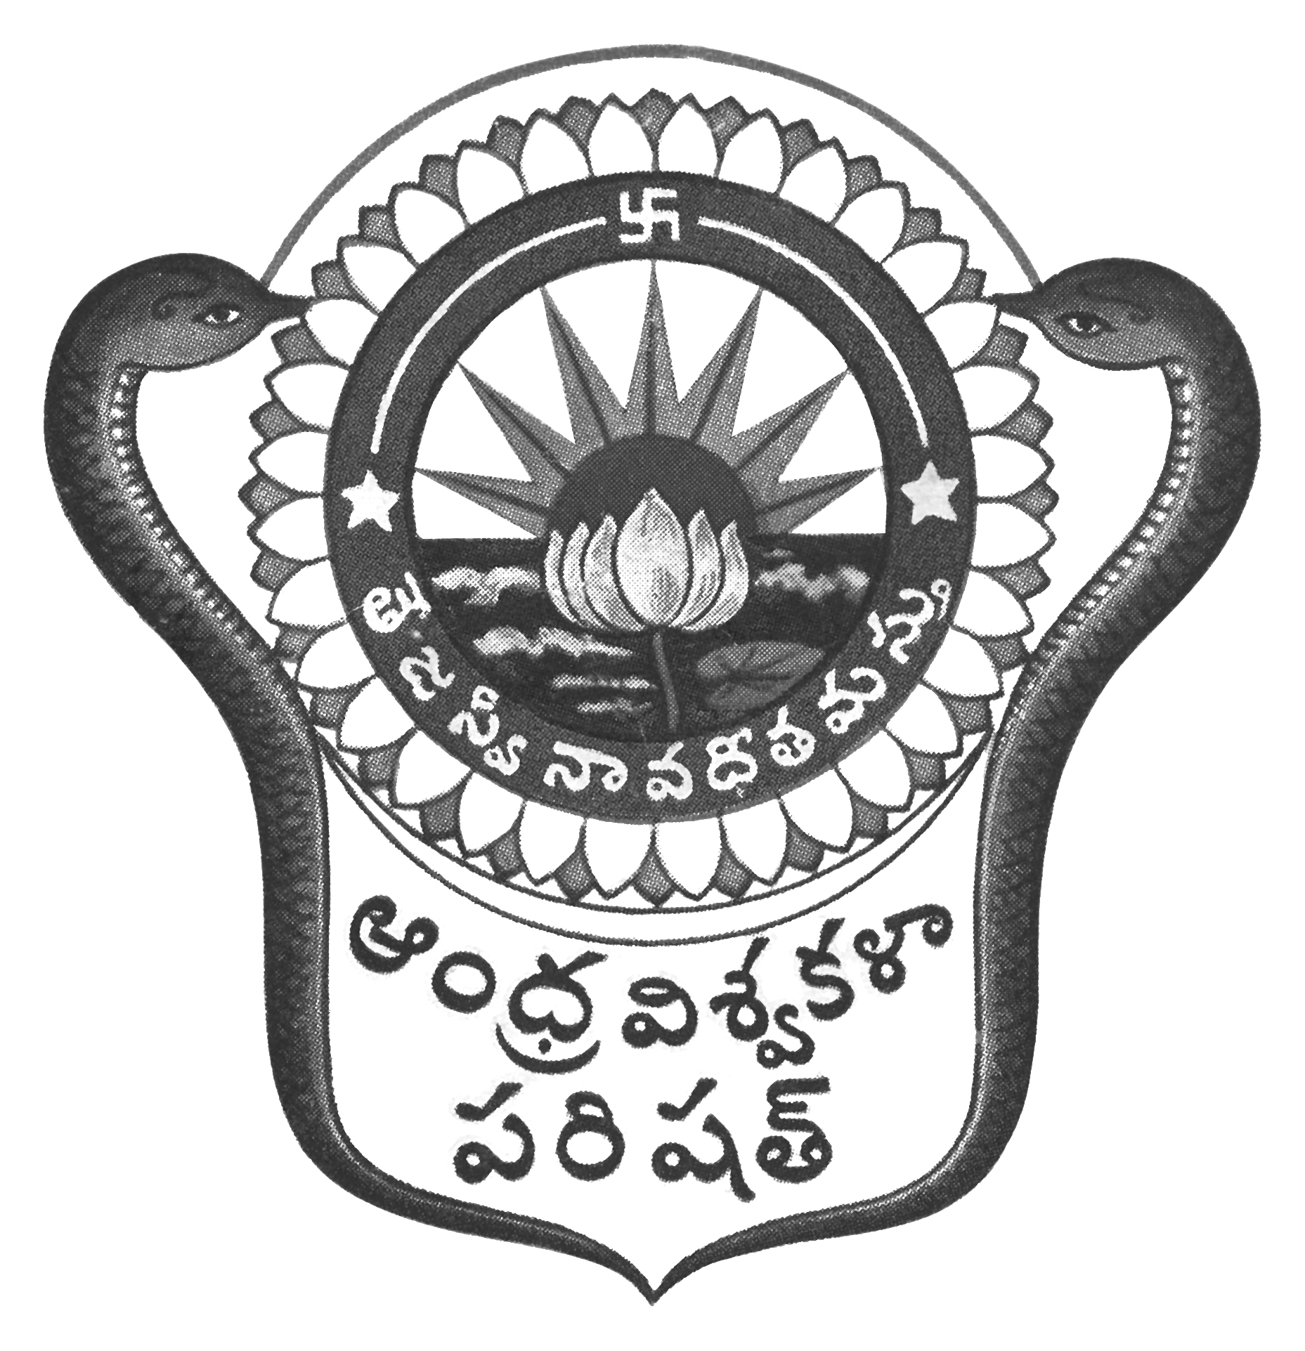
Prof.N.Vijay Mohan, M.P.Ed., DNIS., NIS., PG.DSM, Ph.D.  Director of Physical Education,  Secretary, AU Sports Board,  Dept. of Physical Education & Sports Sciences  Andhra University  Visakhapatnam-530 003 (AP) | 0891-2844496  vijaymohansports@gmail.com  ausportsvsp@gmail.com  Web: andhrauniversity.edu.in

No.AUSB/ICGS-IUT/Circular-02/2023-24 Date: 27-10-2023

To
The Principals,
Affiliated Colleges of Andhra University,

Sir/Madam,

Sub: - Andhra University team Selections Trails 2023-24 – Reg.

&&&

The Andhra University team selections to the following events will be conducted on the dates and venues noted against the events. The players should report at the venue with the necessary eligibility along with Four passport size photographs duly signed by the Principal (Facsimile not allowed) on the reverse side on the photograph and pinned to the eligibility Performa and Aadhar card Xerox copies. Students born on or after 01-07-1998 are eligible. The players should report at 8.00 AM to the Organizing Secretary with eligibility.

S.No | EVENT | DATE | VENUE
01 | Football (M) Inter-Collegiate – cum – University  Team selection trials | 04 - 06 November 2023 | AU Golden Jubilee Grounds, Andhra University  Contact: 6303747410, 7010575007
02 | Boxing (M) Inter-Collegiate – cum – University  Team selection trials | 04/11/2023 | AU Indoor Gymnasium, Andhra University  Contact: 7010575007, 8008586586
03 | Boxing (W) Inter-Collegiate – cum – University  Team selection trials | 05/11/2023 | AU Indoor Gymnasium, Andhra University  Contact: 7386588712, 6303747410

Thanking you, Yours sincerely,
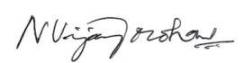
(N.VIJAY MOHAN)
Copy to the Secretary to the Vice-Chancellor, AU
Copy to the P.A. to Registrar, A.U. Visakhapatnam
Copy to all the Principals of Campus Colleges,
Copy to all the Lecturers in Physical Education/Physical Directors
Copy to all the Heads of the Departments and Chief Wardens, A.U. Colleges
With a request to display on NOTICE Board.

